The Counselor Salesperson
Going to market with unique, high-quality products and services is no longer a guarantee that sales will be made and accounts will be retained. Remaining viable in today’s business environment requires salespeople who can respond to customers’ business needs, priorities, and interests better than the competition. Salespeople must be able to quickly discover and understand the business issues related to strategy execution. It all begins with a consultative selling approach—working closely with customers to solve real business problems.
The Counselor Salesperson (CSP) uses a four-step consultative selling process that helps salespeople transition from simply making transactions to solving real business problems. CSP focuses on adopting a Counselor Mindset, a mindset that builds profitable, long-term customer relationships.  Counselor Approach Model  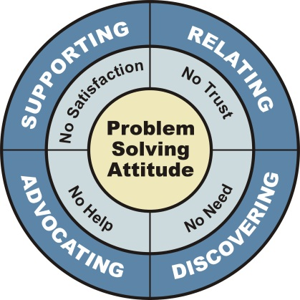  Program Outcomes  The Counselor Salesperson (CSP) establishes a basic philosophy of selling with a common and easily understood approach. CSP provides a win-win approach to selling that emphasizes problem solving from the customer’s point of view.  Implemented as a flexible and integrated Human Performance Improvement (HPI) solution, it enables a consistent customer experience from the salesforce, effective coaching and performance management with a variety of tools, and overall increased sales.  Approach  Wilson Learning believes that learning must be transferred to day-to-day work practices. To achieve |  |  | this, The Counselor Salesperson includes components and activities that enhance:  Participant Readiness: Prepares salespeople and managers for the overall learning experience  - Pre-workshop communication sets the context for learning  Learning Design: Embeds practice and use of new skills in the learning design and the learning can be flexibly delivered as a:  - Three-day, face-to-face application-oriented workshop (Two-day option available)  - Series of instructor-led interactive webcast workshops delivered over time.  The webcast design drives a constant stream of engaging learning activities—whiteboards, breakout rooms, polling, group work, video, real-time work and more.  - Blended solution (with e-learning content followed by an optional application day)  All can be delivered in modular format over non-consecutive days to allow application between sessions.  CSP as a workshop component, can be taught by a Wilson Learning facilitator, or by an organization’s own leader-trained in-house professional.  Organizational Alignment: Ensures that the organization supports the use of the new skills  - Post-learning reinforcement activities for both the manager and salesperson support both skill application and implementation.  As a result, CSP becomes part of your organization’s selling practices which benefits customers and increases productivity.
 | Outcomes by Module
 | Modules: Key Learnings Are… |  |  | Your Salespeople Will…
 | Counselor Mindset  How to understand the selling process as a function of the buying process and learning how to see the role of the salesperson as a consultant or counselor. |  |  | Be able to enter a consultative relationship with buyers and add value at each step of the buying process.
 | Relating  How to build trust at the beginning of a consultative relationship. How to establish credibility, express empathy and come to agreement on the purpose, process and payoff of the relationship. |  |  | Be able to quickly establish trust with any person in the buying process and gain that person’s willing cooperation in sharing information.
 | Discovering  How to understand the buyer’s needs by asking appropriate fact and feeling finding questions and learning how to listen and organize information and learning to get the buyer’s agreement on the true nature of the problem. |  |  | Be able to gain an in-depth agreement with the buyer about the real nature and scope of the problem to be solved.
 | Advocating  How to develop and present solutions that clearly address and solve the customer’s business problems. How to bring out concerns, resolve objections and agree on next steps. |  |  | Be able to convince buyers that a particular offer is a valuable solution to their business problem.
 | Supporting  How to reinforce and support the customer’s decision to buy. How to avoid and resolve dissatisfaction. How to ask for new business and referrals. |  |  | Be able to assure a high degree of customer satisfaction and enhance the working relationship after the sale.

Enabling Improved Performance  The Counselor Salesperson (CSP) features various performance application, reinforcement, and support tools. These additional learning components—application exercises, job aid cards, electronic reinforcement tools, performance checklists—ensure that salespeople can hone newly acquired skills and behaviors upon returning to work. Involving sales managers early on, and training them to coach for improved performance, is also fundamental to a successful CSP implementation.  Measurement  Organizations that implement The Counselor Salesperson have access to measurement and evaluation tools. Beyond tracking sales efforts with the planners and performance checklists, the Win-Loss Review helps sales managers and their salespeople track the actual impact of counselor selling skills on real sales performance.  Wilson Learning’s (optional) Customer Relationship Inventory (CRI) assessment instrument uncovers what customers really think about an organization’s salesforce. This concrete, real-world feedback motivates |  | salespeople to perform, and acts as a blueprint for creating individual, group, and organizational development plans.  Wilson Learning’s (optional) CSP Challenge assessment instrument supports the application of skills from the CSP program. This tool is an effective way to help managers coach their salespeople more effectively, to extend the transfer of CSP skills back to the job, and to diagnose salespeople’s CSP skills prior to the learning.  Evaluation  In most implementations, Wilson Learning will partner with your organization to measure the initial behavioral changes and business results. Our common interest in making sure that The Counselor Salesperson delivers the results you seek. We are committed to helping you succeed. We will work with you to set up measurement systems to help move desired change forward and sustain the momentum of your implementation.  This offering, like all others from Wilson Learning, can be customized to reflect your sales environment and business priorities, and integrated with your sales process.

